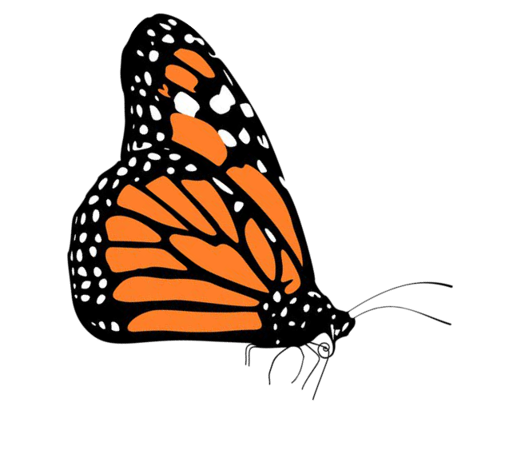

**1, 2, 3...for the Butterflies and Bees Program Application**

Thank you for considering the Riverside-Corona Resource Conservation District's 1, 2, 3...for the Butterflies and Bees pollinator habitat kit program. Any resident or community entity such as a library, school, community garden, farm, business, community center, etc., located within the [RCRCD district boundary](https://www.rcrcd.org/district-boundary-map), is welcome to apply for a **free** kit. Approximately 50-60 kits will be available each year and priority will be given to those individuals or entities located in an underserved community. Two to four different kits will be available to choose from year to year and plant species will vary depending on plant availability. Each kit will cover approximately 150-1000 square feet, depending on kit type and planting layout. Those that apply but do not receive a kit due to availability, will be placed on a waiting list and receive priority for the following year.

One kit per applicant. Applicants who receive a kit are not eligible to reapply.

Please answer the questions below. Completed applications and program questions should be emailed to RCRCD Naturalist, Michele Felix-Derbarmdiker, at [Felix-Derbarmdiker@rcrcd.org.](mailto:Felix-Derbarmdiker@rcrcd.org)

Applicant Name:

Group or community entity:

Address (Where will the plants be planted?):

Email address:

Phone number:

How did you hear about our program?

Kit type (Plants in each kit are listed on the next page):

Sun Kit Partial Shade Kit Mini Sun Kit Mini Shade Kit

Provide a short description of where the kit will be planted:

Provide a short description of why you are interested in our program:

Are you currently experiencing transportation hardship, unable to drive or live in an area lacking public transportation? Yes No

If yes, would you like your kit(s) delivered to your home or planting site? Yes No

A plant information sheet will be included with your kit. Would you prefer the information sheet to be in Spanish or English? Spanish English



**2024 Habitat Pollinator Kit Plant List**

Mini kits consist of one medium sized shrub and several smaller plants

# Sun (Plants that tolerate 6+ hours of daily direct sunlight):

|  |  |
| --- | --- |
| **Species** | **Common Name** |
| Asclepias fascicularis | Narrow Leaf Milkweed |
| Bouteloua gracilis | Blue Gama |
| Eriogonum arborescens | Santa Cruz Island Buckwheat |
| Eriogonum fascicularis var foliolosum | Leafy California Buckwheat |
| Linum lewisii | Prairie Flax |
| Monardella villosa | Coyote Mint |
| Penstemion palmeri | Palmer's Penstemon |
| Penstemon heterophyllus | Foothill Penstemon |
| Salvia apiana | White Sage |
| Salvia 'bees Bliss' | Bee's Bliss Sage |
| Salvia clevelendii | Cleveland Sage |
| Salvia mellifera | Black Sage |
| Solidago vetulina ssp. Californica | California Goldernrod |
| Tetraneuris acaulis | Stemless Four Nerve Daisy |
| Verbena lilacina | Liliac Verbena |
| Annual Flower Seed Packet | Variety |

Partial Shade (Plants that tolerate part shade or dry shade conditions):

|  |  |
| --- | --- |
| **Scientific Name** | **Common Name** |
| Asclepias fascicularis | Narrow Leaf Milkweed |
| Monardella villosa | Coyote Mint |
| Penstemon heterophyllus | Foothill Penstemon |
| Prunus ilicifolia | Hollyleaf Cherry |
| Diplacus longiflorus | Bush Monkeyflower |
| Epilobium canum | California Fuchsia |
| Gambelia speciosa 'Firecracker' | Firecracker Showy Island Snapdragon |
| Muhlenbergia rigens | Deergrass |
| Ribes viburnifolium | Catalina Currant |
| Salvia spathacea | Hummingbird Sage |
| Annual Flower Seed Packet | Variety |

**Species will vary due to availability. In the name of sustainability, we kindly ask that when feasible, you return empty plant pots to our LandUse Learning Center (4500 Glenwood Dr Riverside, CA 92501). The center is open 7 days a week from 8am to 4pm. Closed holidays. These pots will be cleaned and reused.**